1. 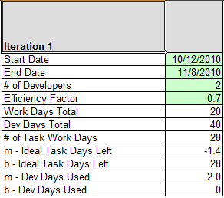**Efficiency Factor** 
   1. Default : 0.7 or 70%
2. **Work Days Total**
   1. Default : 1 month = 20 days
3. **Dev Days Total**
   1. *Work Days Total* * *# of Developers*
4. **# of Task Work Days**
   1. Round (*Efficiency Factor* * *Dev Days Total*)
5. **M-Ideal Task Days Left** 
   1. (-1 * *# of Task Work Days*) / *Work Days Total*
6. **B-Ideal Task Days Left**
   1. *# of Task Work Days*
7. **M-Dev Days Used**
   1. *Dev Days Total* / *Work Days Total*
8. **B-Dev Days Used**
   1. Default : 0

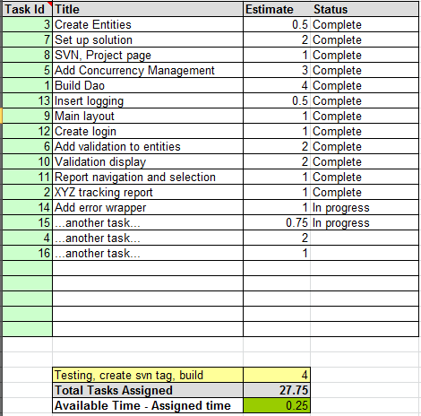

1. **Estimate** = Days (decimal format)

2. **Total Tasks Assigned**

Summation of *Estimates*

3. **Available Time** – Assigned Time

# of *Task Work Days* – *Total Task Assigned*

(I think pag nag positive ang result neto ito ung allowance)

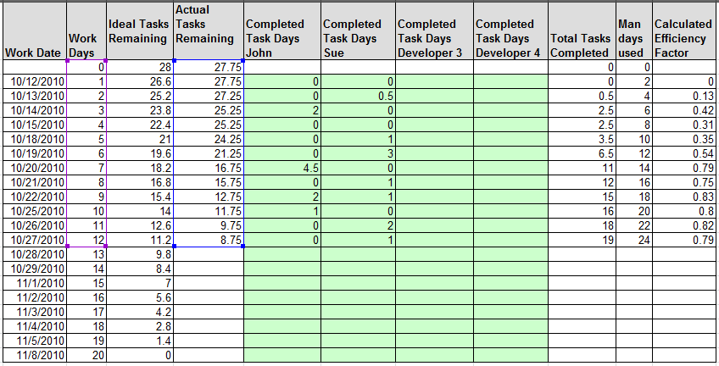

1. First Row : Default Values
   1. **Work Date** = *Start Date* to *End Date* (**exclude non-working Days and holidays**)
   2. **Work Days** = 0
   3. **Ideal Task Remaining** = *# of Task Work Days*
   4. **Actual Tasks Remaining** = *Total Tasks Assigned*
   5. **Total Tasks Completed** = 0
   6. **Man Days Used** = 0
   7. **Calculated Efficiency Factor** = “”
2. Formulas
   1. **Total Tasks Completed** : Summation of *Completed Task Days of all Devs*
   2. **Man Days Used** : Previous *Man Days Used* + *M-Dev Days Used*
   3. **Calculated Efficiency Factor** : Round 2 Decimal Places (*Total Tasks Completed* / *Man Days Used* )

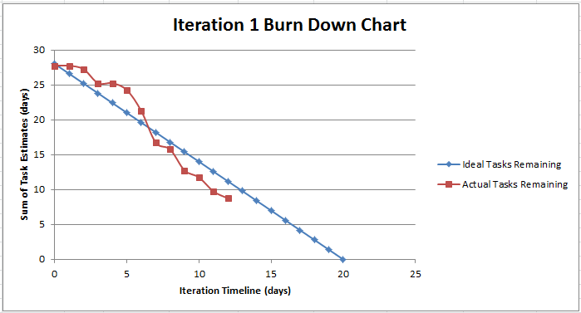

**Ideal Task Series**: Series of (*Ideal Task Remaining* VS *Work Days*)

**Actual Tasks Series**: Series of (*Actual Tasks Remaining* VS *Work Days*)